Triggering Memories: Illustrations & Pictures

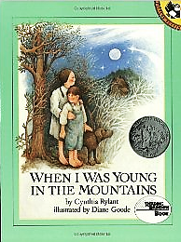

My Memories

Barefoot Children – summertime
Woods – exploring woods at Lake Titus
Night Sky – fishing off dock at night with Dad

